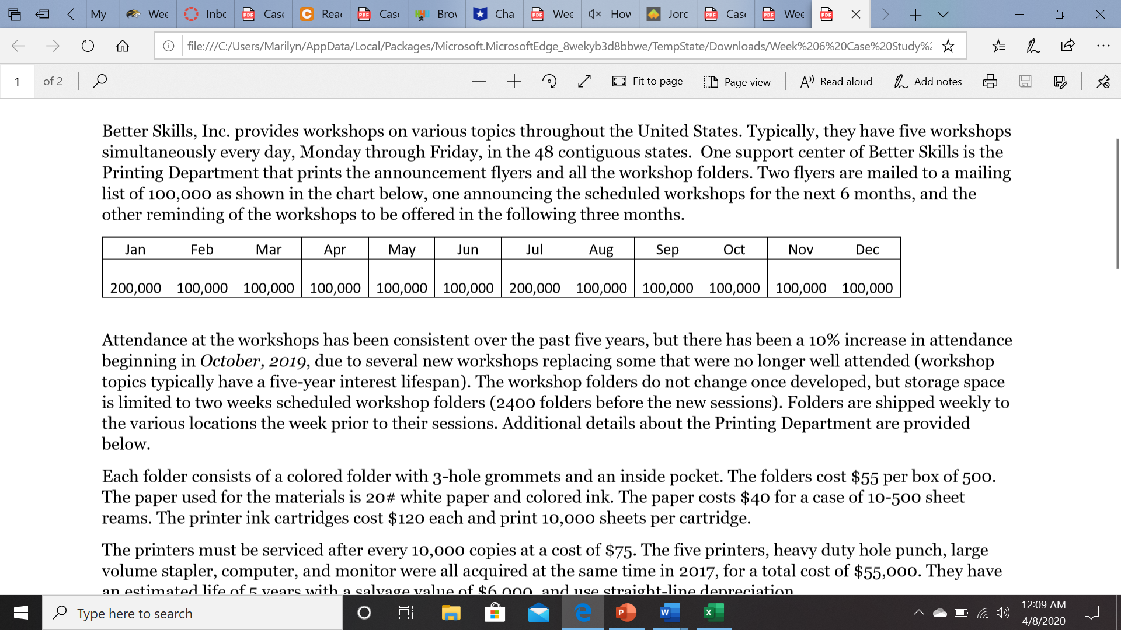
an estimated life of 5 years with a salvage value of $6,000, and use straight-line depreciation.
The Printing Department is staffed by a director, supervisor, two technicians, and an assistant. They all work 40-hour weeks with no overtime at the following rates:
Director: Salary $52,000/year
Supervisor: Salary $45,500/year
Technicians: $18.00 /hour
Assistant: $15.00/hour
Benefits are calculated at 20% of their monthly gross pay.
A monthly overhead allocation is charged to the printing department for electricity, telephones, internet, and cleaning, at a rate of $0.05 per folder prepared.
REQUIRED: Better Skills has asked you to prepare their master budget for their fiscal year of March 2020 to February 2021. They need monthly production, labor, material purchases, income statement, and cash budgets. Use Microsoft Excel utilizing formulas and good statement formatting.

If you make assumptions, please state them. However, your assumptions MAY NOT contradict any facts/data that has been presented in the problem…..

